**Invention Disclosure Form**

# Section A: Inventor Details

1. **INVENTORDETAILS**
   1. **FirstInventor**

|  |  |  |  |
| --- | --- | --- | --- |
| Name | Syed Musthak Ahmed | Mobile No. | 9959876218 |
| Email | syedmusthak_gce@rediffmail.com | Nationality | Indian |
| Address | SR university, Anantha Sagar, Warangal, Telangana, India |  |  |
| Date |  | Sign |  |

# SecondInventor

|  |  |  |  |
| --- | --- | --- | --- |
| Name | L.M.I.Leo Joseph | Mobile No. | 8760255010 |
| Email | leojoseph@sru.edu.in | Nationality | Indian |
| Address | SR university, Anantha Sagar, Warangal, Telangana, India |  |  |
| Date |  | Sign |  |

# Third Inventor

|  |  |  |  |
| --- | --- | --- | --- |
| Name | Ajayan | Mobile No. | 8760255010 |
| Email | j.ajayan@sru.edu.in | Nationality | Indian |
| Address | SR university, Anantha Sagar, Warangal, Telangana, India |  |  |
| Date |  | Sign |  |

# Fourth Inventor

|  |  |  |  |
| --- | --- | --- | --- |
| Name | SreedharKollem | Mobile No. | 9908624167 |
| Email | Sreedhar.k@sru.edu.in | Nationality | Indian |
| Address | SR university, Anantha Sagar, Warangal, Telangana, India |  |  |
| Date |  | Sign |  |

# Fifth Inventor

|  |  |  |  |
| --- | --- | --- | --- |
| Name | Sandip Bhattacharya | Mobile No. | 9563559472 |
| Email | sandip.bhattacharya@sru.edu.in | Nationality | Indian |
| Address | SR university, Anantha Sagar, Warangal, Telangana, India |  |  |
| Date |  | Sign |  |

# Sixeth Inventor

|  |  |  |  |
| --- | --- | --- | --- |
| Name | Alladi Tanmayi | Mobile No. | 9603237356 |
| Email | tanmayialladi@gmail.com | Nationality | Indian |
| Address | SR university, Anantha Sagar, Warangal, Telangana, India |  |  |
| Date |  | Sign |  |

# Seventh Inventor

# 

|  |  |  |  |
| --- | --- | --- | --- |
| Name | Kolipaka Rishwanth | Mobile No. | 7396598371 |
| Email | rishwanthkolipaka@gmail.com | Nationality | Indian |
| Address | SR university, Anantha Sagar, Warangal, Telangana, India |  |  |
| Date |  | Sign |  |

# EighthInventor

|  |  |  |  |
| --- | --- | --- | --- |
| Name | Bathoju Shritha | Mobile No. | 8919021076 |
| Email | shrithabathoju@gmail.com | Nationality | Indian |
| Address | SR university, Anantha Sagar, Warangal, Telangana, India |  |  |
| Date |  | Sign |  |

# NinethInventor

|  |  |  |  |
| --- | --- | --- | --- |
| Name | Boda Shilpa | Mobile No. | 630523535785 |
| Email | Bodashilpa31@gmail.com | Nationality | Indian |
| Address | SR university, Anantha Sagar, Warangal, Telangana, India |  |  |
| Date |  | Sign |  |

# TenthInventor

|  |  |  |  |
| --- | --- | --- | --- |
| Name | Mustafa | Mobile No. | 9490442018 |
| Email | mufatechsolutions@outlook.com | Nationality | Indian |
| Address | Mufatechsolutions |  |  |
| Date |  | Sign |  |

# IP support services you wish for us to fulfill (Please specify the services needed in the space provided for one of multiple choices or simply write SELECT in block letters nextto the serviceneeded): -

* PatentabilitySearch
* Provisional PatentApplication
* Non-Provisional PatentApplication
* Trademark
* Copyright
* Other Drafting Support Services (Industrial Designs,GIs)
* Prosecution Services (FER, EPR, and otherservices)
* Other IP Support Services (FTO, LandscapeAnalysis)

# Point of contact (POC) between Inventors and IPCurate Labs IPR ResearchTeam:

**1st Point of Contact**

**Name**Syed Musthak Ahmed

**WhatsApp** 9959876218

**Calling**9959876218

**Email** syedmusthak_gce@rediffmail.com

1. **Should the first POC be unavailable, we would feel comfortable knowing whom nextto talk to:**

|  |  |
| --- | --- |
| NameL.M.I.Leo Joseph | MobileNo.8760255010 |
| Emailleojoseph.lmi@sru.edu.in | Nationality INDIAN |

**2nd Point ofContact: -**

**Name:**Sandip Bhattacharya

**WhatsApp** 9563559472

**Calling**9563559472

**Email** sandip.bhattacharya@sru.edu.in

1. **Have you previously disclosed your idea to anyone? If so, where, and how have you revealed said information?**

**NO**

**Section B: Your Invention**

1. **INVENTION TITLE:"**"An advanced cardiac arrest detection system with automatic CPR and defibrillation notification alerts to save patient's life"
2. **PROBLEM:** What overall problem(s) does the proposed invention solve or what purpose does it serve? *(Note: Please be specific, spell out acronyms and provide enough laymanlevel detail to fully explain the problem.)*

A potentially fatal illness known as cardiac arrest occurs when the heart abruptly stops beating.Survival rates from cardiac arrest are very low, and the chances of survival decrease with each passing minute. A sophisticated cardiac arrest detection device can detect cardiac arrest before the patient exhibits any symptoms. This early discovery can provide the patient with the highest chance of survival.

CPR and defibrillation are two life-saving procedures that can be used to resuscitate a cardiac arrest patient. However, not everyone knows how to perform CPR or has access to a defibrillator. When a cardiac arrest is identified, an advanced cardiac arrest detection system can automatically contact skilled responders and emergency agencies. This can ensure that the patient receives CPR and defibrillation promptly, which can significantly improve their chances of survival.Survivors of cardiac arrest often experience cognitive and physical impairments. Early detection and treatment of cardiac arrest can help to minimize these impairments and improve the quality of life for survivors.

EXISTING SOLUTIONS / PRIOR ART/RELATED APPLICATIONS &PATENTS:

1. List any known products, or combination of products, currently available to solve thesame problem(s). What is the present commercialpractice?

Automated external defibrillators (AEDs): AEDs are devices that can be used to deliver an electric shock to the heart to restore a normal heart rhythm. AEDs are easy to use and can be used by anyone, even if they have no medical training.

Implantable cardioverter defibrillators (ICDs): ICDs are devices that are implanted under the skin near the collarbone. ICDs continuously monitor the heart rhythm and can deliver an electric shock to the heart if it detects an irregular heartbeat.

Wearable cardiac monitors: Wearable cardiac monitors are devices that can be worn on the body to track the heart rhythm. Some wearable cardiac monitors can also detect cardiac arrest and alert emergency services.

The present commercial practice is to use a combination of these products to improve the chances of survival from cardiac arrest.

1. In what way(s) do the presently available solutions fall short of fully solving theproblem?

Delayedcardiac arrest detection: Current cardiac arrest detection systems are designed to detect cardiac arrest until the patient has already lost consciousness and collapsed. This can delay the initiation of CPR and defibrillation, which can significantly reduce the patient's chances of survival.

Lack of access to CPR and defibrillation: If a patient experiences cardiac arrest while they are alone at homeor public places without any support there is no guarantee that the patient will have access to CPR and defibrillation.

High cost of some solutions: Some of the currently available solutions for cardiac arrest detection and treatment are very expensive. This can make them inaccessible to some people who need them.

Shortfalls due to already existing commercial products

AEDs are not always available in public places, and even when they are, some people may not be able to find them or use them properly.

ICDs: ICDs are expensive and require surgery to implant. They can also malfunction, and they may not be suitable for all patients.

Wearable cardiac monitors: Wearable cardiac monitors are becoming more popular, but they are unfamiliar and expensive. Some patients may be uncomfortable to wear, and they may not be suitable for all people.

1. Conduct key word searches using Google and list relevant prior art materialfound?

* US Patent No. 9,737,261: This patent describes a system and method for detecting cardiac arrest and

providing CPR and defibrillation. The system includes a wearable device that monitors the heart rhythm and can detect cardiac arrest. The device also includes a CPR actuator that can deliver CPR to the patient. The system can also notify emergency services when cardiac arrest is detected.

* US Patent No. 10,414,579: This patent describes a system and method for detecting cardiac arrest and

providing defibrillation. The system includes a wearable device that monitors the heart rhythm and can detect cardiac arrest. The device also includes a defibrillator that can deliver an electric shock to the heart to restore a normal heart rhythm. The system can also notify emergency services when cardiac arrest is detected.

* Automatic CPR device could save lives during cardiac arrest: This article from Science Daily describes

a new device that can automatically deliver CPR to a patient in cardiac arrest. The device is placed on the patient's chest and uses a piston to deliver compressions. The device can also detect the patient's heart rhythm and adjust the compression rate accordingly.

* Implantable defibrillators save lives in people with heart rhythm problems: This article from the Mayo Clinic describes implantable cardioverter defibrillators (ICDs). ICDs are devices that are implanted under the skin near the collarbone. ICDs continuously monitor the heart rhythm and can deliver an electric shock to the heart if it detects an irregular heartbeat.
* Wearable cardiac monitors can help detect heart rhythm problems: This article from the Cleveland Clinic describes wearable cardiac monitors. Wearable cardiac monitors are devices that can be worn on the body to track the heart rhythm. Some wearable cardiac monitors can also detect cardiac arrest and alert emergency services.

# DESCRIPTION OF PROPOSEDINVENTION:

How does your idea solve the problem defined above? Please include details about how your idea is implemented and how it works?

The advanced cardiac arrest detection system with automatic CPR and defibrillation notification alerts and solves the problem of cardiac arrest by providing early detection and treatment. This can help to save lives and improve the quality of life for survivors.

The proposal is to develop a device to monitor vital signs and other indicators of cardiac arrest. Once cardiac arrest is detected, the system would send an alert to trained personnel nearby, such as paramedics or lifeguards. The system would also provide instructions on how to perform CPR and defibrillation for no voice users.

**Detailed Workflow**

* A patient is wearing a wearable device to monitor their vital signs.
* The device detects a sudden change in the patient's vital signs that is indicative of cardiac arrest.
* The device sends an alert to trained smart models.
* The trained personnel arrive at the scene and assess the patient's condition.
* If the patient is in cardiac arrest, the intelligent algorithm perform CPR and defibrillation.
* The wearable device provides the smart model with feedback on their CPR and defibrillation technique.
* The trained personnel will be informed if smart system attempts failedto provide CPR and defibrillation until the patient's heart rhythm returns to normal.

This concept redefines cardiac arrest detection system by considering the smart system training profile to attempt cardiac failures. It leverages AI for real-time estimation early cardiac test and recovery during smart device modelling aspect. It represents a promising innovation in cardiac arrest detection to improve treatment assistive outcomes and reduce complications associated with cardiac arrest and its recovery.

1. **NOVELTY:** Please provide a **one-sentence**description of what distinguishes youridea from the prior art. This is a statement of what is new, and not a businesscase.

Unlike existing methods, our invention employs a smart modeltrained with self generative algorithms to intelligently predict, detect, and autonomously remediate cardiac arrests, effectively transforming traditional paramedical practices into a proactive, machine assistive solution.

**COMPARISON:** Please provide advantages and basic differences of the proposed solution over previoussolutions.

Advantages:

Early detection: Smart assistive cardiac arrest mechanisms can detect cardiac arrest earlier than previous solutions, which can lead to better outcomes for patients. This is because they can monitor vital signs and other indicators of cardiac arrest more continuously and accurately.

Automatic notification: Smart assistive cardiac arrest mechanisms can automatically notify trained personnel when cardiac arrest is detected. This can help to ensure that patients receive prompt treatment, even if they are alone or in a remote location.

CPR and defibrillation assistance: Smart assistive cardiac arrest mechanisms can provide assistance with CPR and defibrillation. This can be helpful for bystanders who are not trained in CPR or defibrillation, or who are feeling overwhelmed in an emergency situation.

Basic differences:

Smart assistive cardiac arrest mechanisms use artificial intelligence (AI) to detect cardiac arrest and provide assistance with CPR and defibrillation. Previous solutions did not use AI, and therefore were not as accurate or effective.

Smart assistive cardiac arrest mechanisms can be integrated with wearable devices and other sensors to monitor vital signs and other indicators of cardiac arrest more continuously and accurately. Previous solutions were typically standalone devices that were not integrated with other systems.

Smart assistive cardiac arrest mechanisms can be connected to the internet, which allows them to send alerts to trained personnel and receive assistance remotely. Previous solutions were typically not connected to the internet.

Overall, smart assistive cardiac arrest mechanisms offer a few advantages over previous solutions. They can detect cardiac arrest earlier, automatically notify trained personnel, and provide assistance with CPR and defibrillation. These advantages can lead to better outcomes for patients.

1. **ADDITIONAL INFORMATION:** Please provide additional information such as, aclaim set, drawings, a software code,etc.).

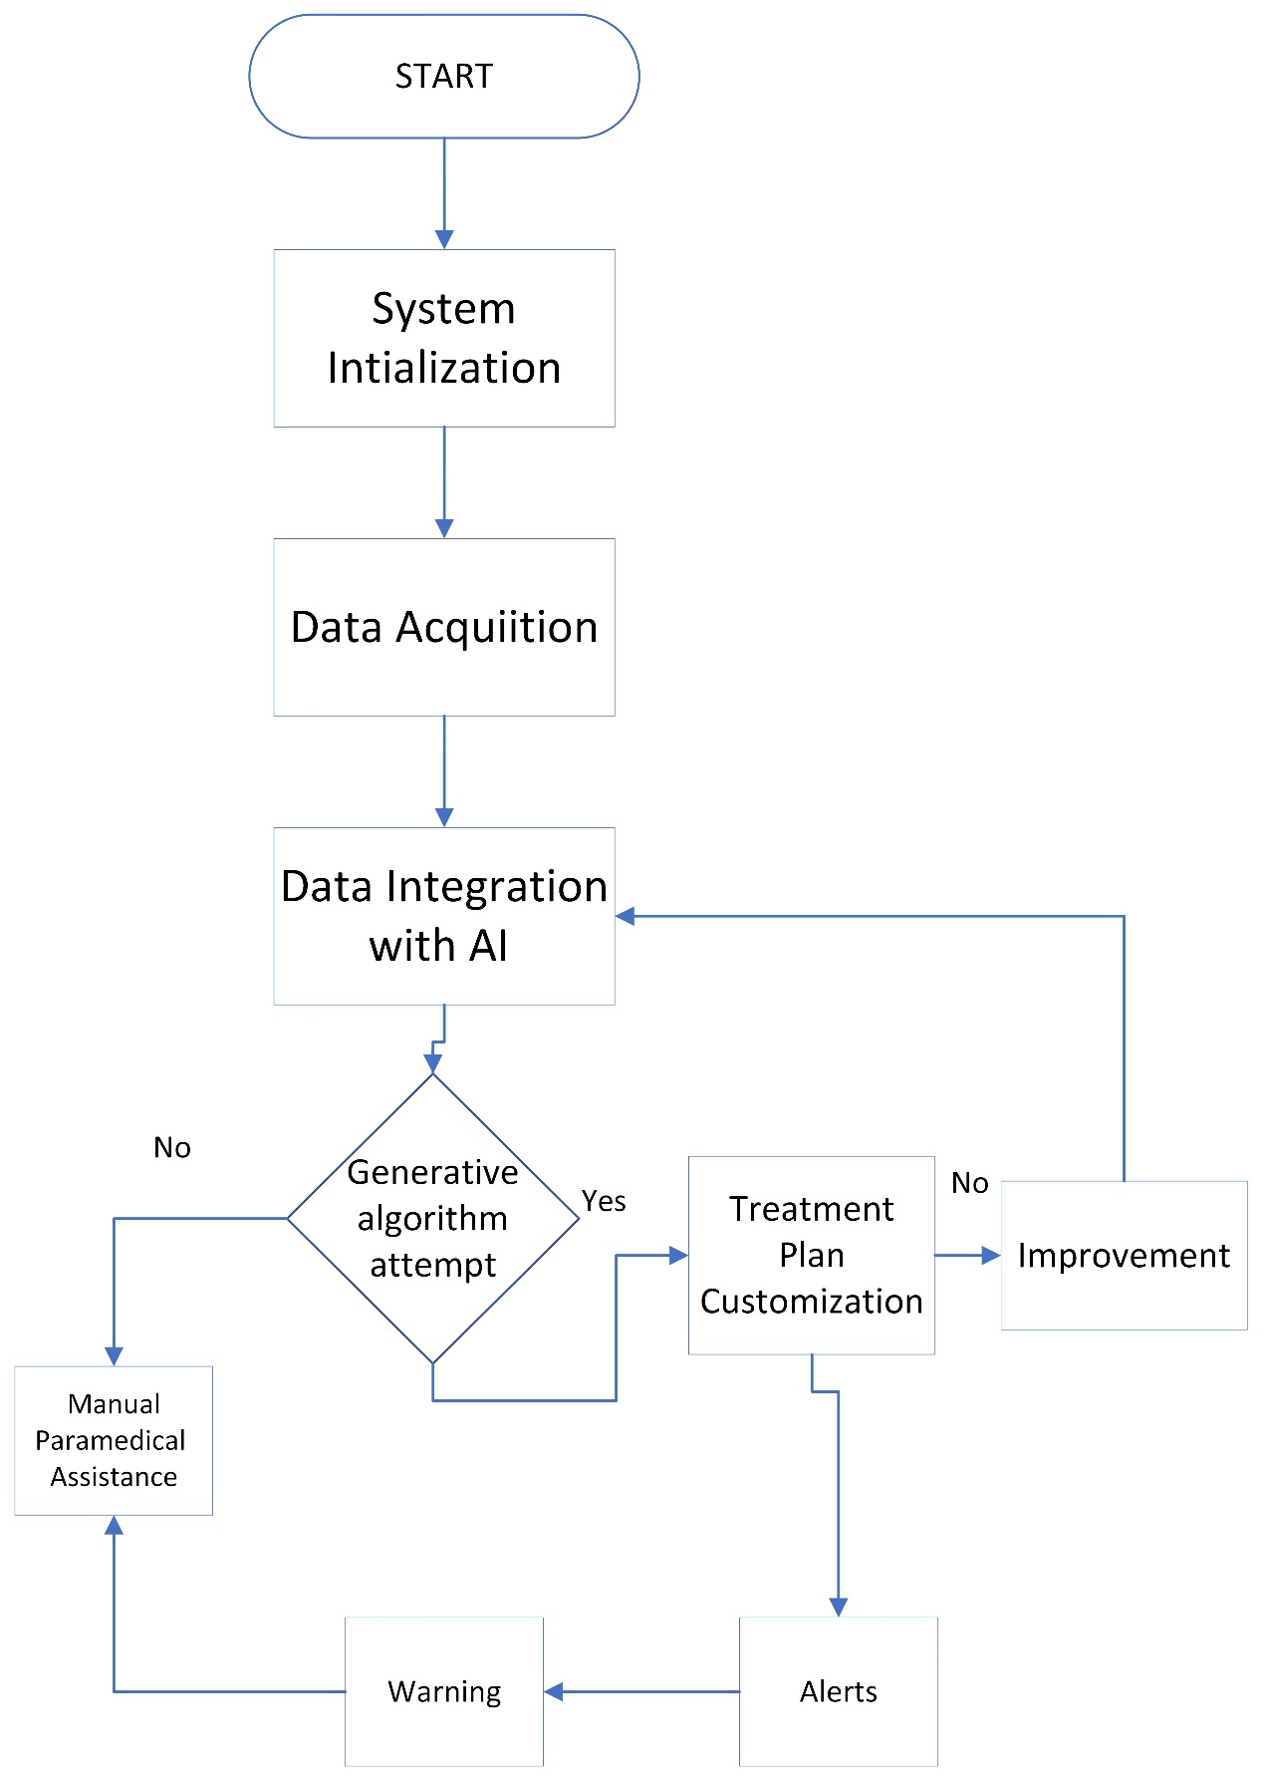

1. **CLAIMS**

Claim 1:

A system for autonomous detection and remediation of cardiacarrset

Claim 2:

The system of claim 1, wherein said smart agents to provide comprehensive data collection capabilities.

Claim 3:

The system of claim 1, wherein said central control system further comprises a data storage mechanism ensuring the integrity and security of collected data.

Claim 4:

The system of claim 1, wherein said smart agents are equipped with specialized generative algorithm to initiate recovery action.

Claim 5:

A method for intelligent detection and remediation of cardiac arrest in a sewer system using smartagents

Claim 6:

The method of claim 5, wherein said machine learning algorithms continuously learn from real-time data, improving predictive accuracy and overall system efficiency.

Claim 7:

The method of claim 5, further comprising utilizing augmented reality technology to provide real-time visualization and guidance for maintenance personnel during the remediation process.